


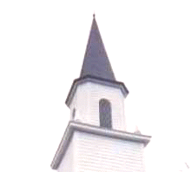
A time of fellowship, worship and prayer amongst your Ironman Competitors, spectators and the local community.
For where two or three come together in my name, there am I with them. _{Matthew 18:20}
Thur. , Oct 19th, 2006, 4-5pm

200yds from race start on Ali'i Dr., across from the Palace

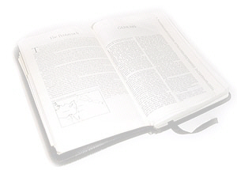
Please come to meet others, share testimonies, and worship in prayer.
Guest Speaker, 3 time IM Champion, Heather Gollnick
www.ictrinet.com | www.ironprayer.com | www.Mokuaikaua.org

A time of fellowship, worship and prayer amongst your Ironman Competitors, spectators and the local community.
For where two or three come together in my name, there am I with them. _{Matthew 18:20}
Thur. , Oct 19th, 2006, 4-5pm
200yds from race start on Ali'i Dr., across from the Palace
Please come to meet others, share testimonies, and worship in prayer.
Guest Speaker, 3 time IM Champion, Heather Gollnick
www.ictrinet.com | www.ironprayer.com | www.Mokuaikaua.org

A time of fellowship, worship and prayer amongst your Ironman Competitors, spectators and the local community.
For where two or three come together in my name, there am I with them. _{Matthew 18:20}
Thur. , Oct 19th, 2006, 4-5pm
200yds from race start on Ali'i Dr., across from the Palace
Please come to meet others, share testimonies, and worship in prayer.
Guest Speaker, 3 time IM Champion, Heather Gollnick
www.ictrinet.com | www.ironprayer.com | www.Mokuaikaua.org

