


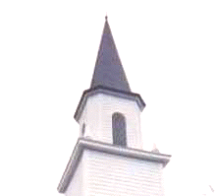

A time of fellowship, worship and prayer amongst your Ironman Competitors, spectators and the local community.
For where two or three come together in my name, there am I with them. _{Matthew 18:20}
Thur. , Nov tbd, 2006, 3-4pm

Gulf Beach Baptist Church
A few minutes from race site on Middle Beach Rd.


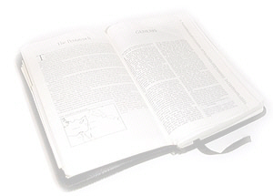
Please come to meet others, share testimonies, and worship in prayer.
www.trinitytriathletes.org | www.ironprayer.com | www.gulfbeachbaptist.org

A time of fellowship, worship and prayer amongst your Ironman Competitors, spectators and the local community.
For where two or three come together in my name, there am I with them. _{Matthew 18:20}
Thur. , Nov tbd, 2006, 3-4pm
Gulf Beach Baptist Church
A few minutes from race site on Middle Beach Rd.

Please come to meet others, share testimonies, and worship in prayer.
www.trinitytriathletes.org | www.ironprayer.com | www.gulfbeachbaptist.org

A time of fellowship, worship and prayer amongst your Ironman Competitors, spectators and the local community.
For where two or three come together in my name, there am I with them. _{Matthew 18:20}
Thur. , Nov tbd, 2006, 3-4pm
Gulf Beach Baptist Church
A few minutes from race site on Middle Beach Rd.

Please come to meet others, share testimonies, and worship in prayer.
www.trinitytriathletes.org | www.ironprayer.com | www.gulfbeachbaptist.org

