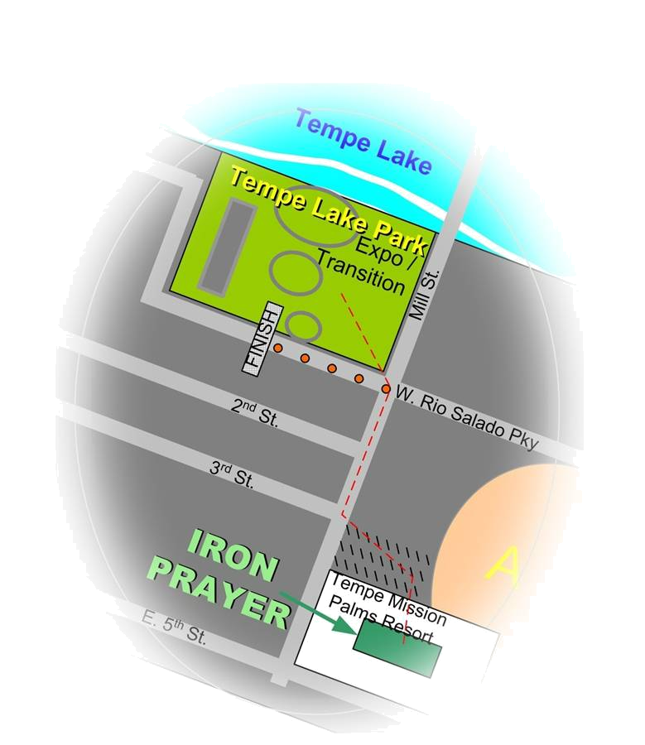

Fri, Apr 7th, 2006, 4-5pm

Delores Room, inside the courtyard
.5mi from Expo



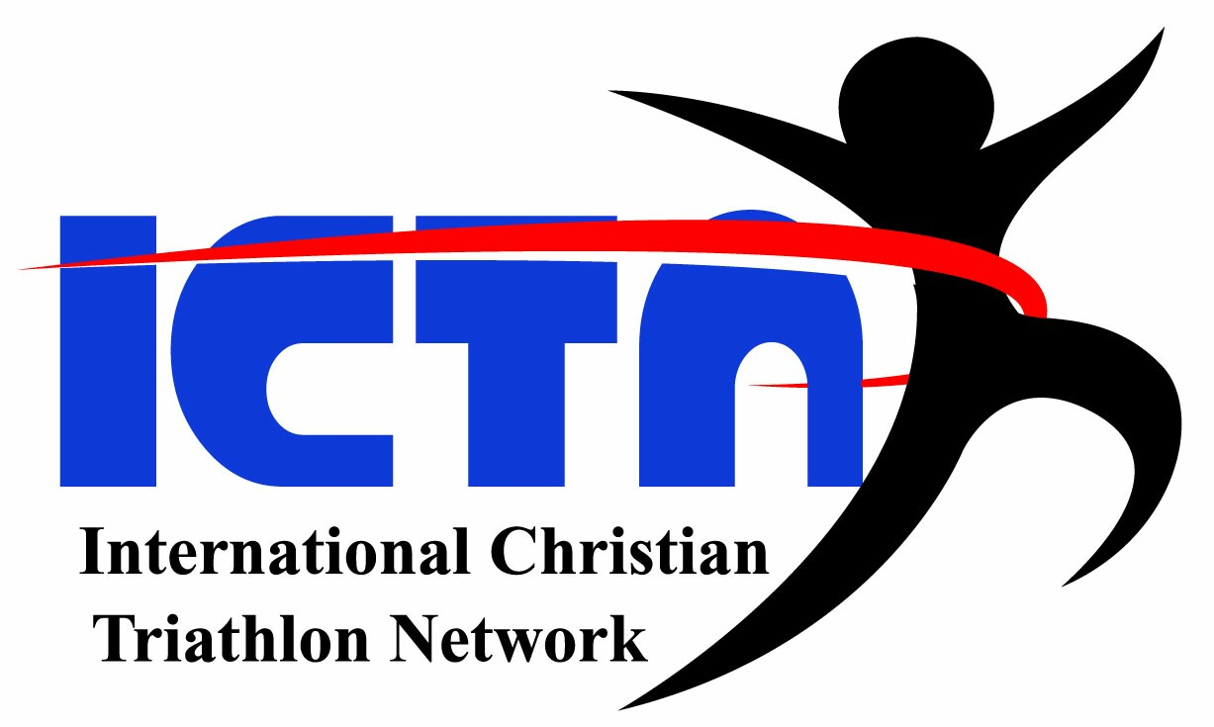
www.ictrinet.com
For where two or three come together in my name, there am I with them. _{Matthew 18:20}
A time of fellowship, worship and prayer amongst your
Ironman Competitors, spectators and the
local community.
Guest Speaker
Heather Gollnick

Ministries
www.ironprayer.com
www.trinitytriathletes.org

- Meet others
- Be inspired by testimonies
- Share in Worship & Prayer, together.
Please come and…

