
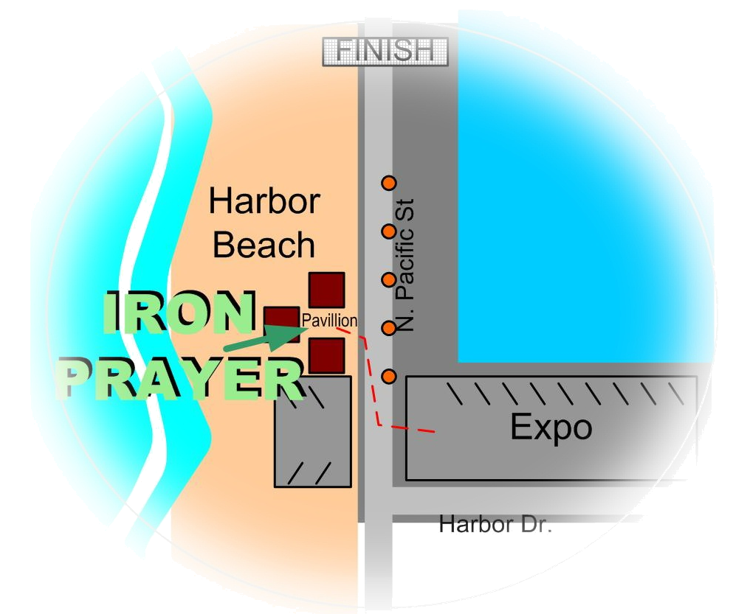
Fri, Mar 17th, 2006, 5:15-6:15pm

Across from Expo entrance,
on N. Pacific St.

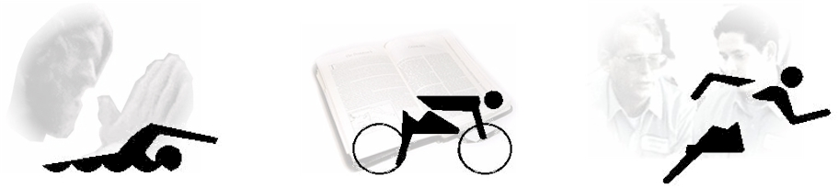

Meet others
Hear great music
Be inspired by testimonies
Share in Worship and Prayer, together.
Please come and…
A time of fellowship, worship and prayer amongst your
Ironman Competitors, spectators and the
local community.
Worship Music by
Hollowell
www.hollowellmusic.com
Guest Speaker
Ken Sacher
For where two or three come together in my name, there am I with them. _{Matthew 18:20}

Ministries
www.ironprayer.com
www.trinitytriathletes.org

NORTH COAST

CALVARY CHAPEL
www.northcoastcalvary.org

