IRONMAN Wisconsin

…and fellowship with other athletes and friends

"For where two or three gather together because they are mine, I am there among them."
Matthew 18:20

THIS WILL REALLY PREPARE YOU FOR THE RACE.

Everyone IS Welcome!
Join us for prayer at the water fountain in front of Monona Terrace immediately following the mandatory race meeting on Saturday, September 14.
&
Same site Sunday morning before the race at 6:00 a.m.
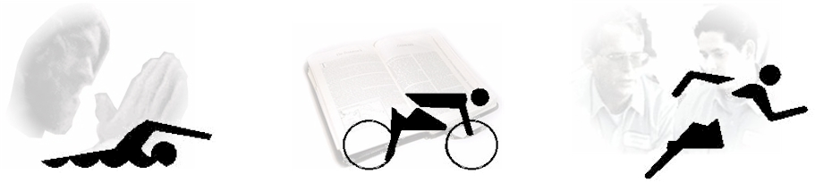

For I can do everything with the help of Christ who gives me the strength I need. - Philippians 4:13

Non-Denominational

Presented by: IRONPRAYER ministries: www.ironprayer.faithweb.com

Check out the website for other IRONPRAYER services at upcoming events.

