IRONMAN UTAH

…and fellowship with other athletes and friends

"For where two or three gather together because they are mine, I am there among them."
Matthew 18:20

THIS WILL REALLY PREPARE YOU FOR THE RACE.

Everyone IS Welcome!

Thursday, June 6th from 3-4 p.m.

Provo Bible Church
1449 West 1150 South - Provo, UT
See the map on the back!
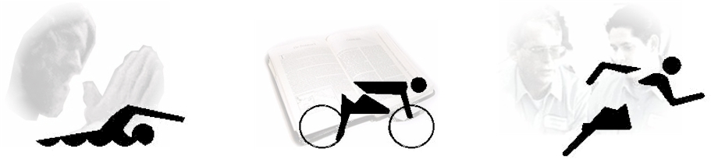

For I can do everything with the help of Christ who gives me the strength I need. - Philippians 4:13

Please come to meet others, share testimonies, and join in worship & prayer.
Non-Denominational

Leaders: Triathletes - Bob Brubaker, Glenn Peroni, & Scott Bennefield

Presented by: IRONPRAYER ministries: www.ironprayer.faithweb.com
Check out the website for other IRONPRAYER services at upcoming events.

