Tri4Christ/FCA Ministry Report – Ironman® Arizona Outreach, April 6-9, 2005

Introduction
In early April, Tri4Christ (“T4C”) traveled to Tempe, Arizona to participate in a joint outreach at Ironman® Arizona (“IM Arizona”) with several of its partner ministries within the International Christian Triathlon Network (“ICTN”) (http://www.ictrinet.com).
T4C and its ICTN ministry partners are increasingly active in reaching out to a community that is loaded with educated, wealthy, and successful people. These are folks who appear to “have it all figured out” but who, in some cases, are not as self-assured or as happy with their self-directed lives as they might like others to think.
Our outreach was targeted to meet these athletes at one of their biggest gatherings: an Ironman race. We chose IM Arizona for a couple of reasons, not the least of which was on-the-ground support from one of our ministry partners, All Nations Church Racing Team of Peoria, Arizona. We also wanted to capitalize on the race’s position early in the triathlon season. Our hope was to build momentum for our 2005 initiatives at this race and carry that momentum forward through the entire race season.
By His provision, we enjoyed a great time of fellowship, praise, and connection with other triathletes. The following report provides the details of our experience at IM Arizona.

Beginnings

The idea of ICTN and of doing a "big" event to start the 2005 triathlon season was first hatched during a dinner meeting in Richmond in July 2004. Present that evening were Lincoln Murdoch, President of the Antioch Network and pastor of All Nations Church in Peoria, Arizona, Tom Keeley of Athletes in Action Triathlon (“AIA”), Aaron Bull of CBN, and Stan Smith, representing T4C/Fellowship of Christian Athletes (“FCA”). At this meeting, the founding members of ICTN finalized discussions concerning the formation of a network of Christian triathletes. ICTN was, effectively, launched out of that meeting. It was also agreed that the network’s first collaborative effort would be a group effort to participate in the pre-race expo for Ironman Arizona. We split up the work and set about trying to make this a reality.

Prayers

"Ask me of gifts for yourself. Are there not any you would wish to name that would make you happier in yourself, more useful and pleasing to others? Tell me the whole list of favors you want of me. Tell me them with humility, knowing how poor you are without them, how unable you are to gain them by yourself; ask for them with much love, and that they may make you more pleasing to me." - Anonymous
The excerpt printed above is from an anonymous prayer, written as if from God’s own invitation to come to Him in prayer. The process described in this prayer is in many ways emblematic of the process that the participating ICTN ministries and their representatives went through during the planning for this outreach. This is especially true in the sense that the ICTN member ministries brought to Him the "whole list," along with our inability to "gain them by [ourselves]."
In order for the operation to be a success, we knew we needed to bathe it in prayer. Specifically, we prayed for God to grant us success in accomplishing the following objectives:
- Getting permission from Ironman North America in order to participate in the pre-race expo;
- Raising the money for a spot at the expo (a couple of thousand dollars);
- Getting a group of people together who could help man the table over the course of several days;
- Finalizing the copy and look/feel for a triathlon-specific "tract";
- Finalizing the copy and text for a packet insert;
- Finding a speaker for our pre-race prayer service;
- Getting people to come by the table and to the pre-race prayer service with open hearts and open minds.

… and Answered Prayers

God answered these prayers. In fact, God not only answered the prayers that we knew we needed to pray; He also answered the prayers we didn't even know we needed to pray. Every good thing that happened leading up to, during, and after Ironman Arizona was the result of God's direct intervention on our behalf and on behalf of the people we came in contact with. We couldn't have done any of this without Him. None of the glory for this is ours; it is His and His alone.

- To get permission from Ironman North America in order to participate in the pre-race expo. One of our original concerns was getting permission to be present at the expo. In this day and age, we cannot take for granted that standing up for Christ in public will be tolerated or allowed in a commercial context. With the help and advice of David Yates, a former President of the World Triathlon Corporation (WTC does the licensing for all of the Ironman®-branded races worldwide), we navigated this initial step without incident.
- Raise the money for a spot at the expo (a couple of thousand dollars). With the help of triathletes from all over the company, $2000 was raised to secure a place at the race expo. Without the contributions and event-specific support of these athletes, including particularly generous contributions from T4C athletes, the outreach would not have been possible.
- Get a group of people together who could help man the table over the course of several days. T4C and AIA each sent representatives to Arizona, and Arizona-based athletes contributed their time to make up the rest of our booth contingent. (No T4C funds were used for transportation or lodging; these were all provided for outside of “program funds.”)
- Finalize the copy and look/feel for a triathlon-specific "tract". With the help of Step Up To Life Ministries of Omaha, Nebraska, the ICTN team collaborated on a triathlon-specific brochure/tract that can be used going forward by all of the ministries. The availability of these brochures in time for distribution at IM Arizona was another key element of the outreach that fell into place by God’s grace.
- Finalize the copy and text for a packet insert. Each athlete in the race – there were over 2500 entrants – gets a race “packet” with free stuff and information; our participation in the expo allowed us to get information concerning our ministries into the race packet. This was a real benefit in terms of getting the word out about our event, and in enabling us to send folks home with information and email addresses about our ministries.
- Find a speaker for our pre-race prayer service. Early on, we had hoped to have Heather Gollnick speak at the pre-race prayer service. Heather is a pro triathlete who is also a wife and mother of 3 children, ages 8, 8, and 5. One of her children has cerebral palsy. Heather is an accomplished triathlete, and has won 3 Ironman races: twice at Ironman Wisconsin, and once at Ironman Coeur d’Alene. However, she was moving during the winter from Wisconsin to Florida, and her sponsorship obligations and race schedule were up in the air during much of early 2005. As a result, we were not sure if we would be able to have her there for our event. However, just a few weeks out from the race, she was able to commit to racing at IM Arizona, and also agreed to speak at the pre-race prayer service.
- Get people to come by the table and to the pre-race prayer service with open hearts and open minds. There is more about this in the next section, but there is no doubt that this prayer was answered in abundance. We spoke to people from all over the country and the world, including a Catholic from Poland, a Jew from South Africa, and a family of triathletes from Mexico City.

Great Expectations

We’ve been invited with the Son
We’ve been invited to come and …
Believe the unbelievable
Receive the inconceivable
And see beyond our wildest imagination
Lord, we come with great expectations
"Great Expectations" -- Steven Curtis Chapman

There were a lot of last minute tasks to attend to in the week leading up to the race, so there was not a lot of discussion about specific objectives. Instead, most of the ICTN team was focused on nailing down the final details so that everything would go smoothly in Tempe.

As a result, we did not go into the event with a discrete list of objectives, and we didn’t really know what to expect. As it turned out, whatever we could have imagined or expected, God provided more.

The expo was outdoors at the Tempe Beach Park, and our position on the “Avenue of Vendors” was ideal; pretty much dead center. We had lots of help from, and great fellowship with members of Lincoln Murdoch’s church, as well as from other members of the Arizona triathlon community, as well as from Tom Keeley of Athletes in Action Triathlon, who came in from Virginia to help. During the several days that the booth was manned, we met hundreds of Christian triathletes and other triathletes, industry folks, family members, volunteers, and passerby who were interested in or curious about our network and the information that we were passing out.

We generated a fair amount of interest via the flyer that was part of each athlete’s race packet. In addition to the flyer, we also had available at the booth copies of Lincoln’s book, See You At The Finish Line, copies of the FCA New Testament, our new triathlon-specific brochure (featuring Heather Gollnick on the cover), and lots of temporary tattoos from the various participating ministries.

The numbers on the outreach are as follows:

- Several hundred people stopped by the booth
- We passed out an estimated 200+ copies of our new triathlon specific-brochure entitled “Are You Ready to TRI This Race?”
- We had over 100 people sign up for information about ICTN and/or the member ministries
- We had 78 people (standing room only) attend our Thursday evening prayer service featuring:
    - A world premiere video from local Ironman athlete J.R. Rosania
    - A talk by Heather Gollnick
    - A screening of Dick and Rick Hoyt racing Ironman, set to music by Nicole C. Mullen (“My Redeemer Lives”).

During our pre-race prayer service, we had corporate prayer and group breakout sessions where athletes and their family members and friends were able to share race-specific and more general prayer requests. It was an emotional and impacting time of fellowship and worship, and we believe it was a highlight of the race week for those who were present. At the end, athletes traded names and race numbers so they could pray for one another leading up to and during the race. Lincoln encouraged those present to great one another when passing each other out on the racecourse with a call-and-response encouragement based on Eric Liddell’s famous statement “When I run, I feel His pleasure.”

Heather’s talk was very effective, inspirational, and balanced. She talked about her own concerns which have as much, if not more, to do with the normal everyday issues of managing a marriage and a home as they do with her career as a pro triathlete. She was very gracious with her time, and signed autographs for some time after the service, providing words of encouragement to the age groupers in attendance.

The Race

To describe the race would require more space than this report will allow. In the coming weeks, we hope to be able to gather some of the race reports from the T4C and ICTN athletes and post them on the T4C/FCA Endurance and ICTN websites.

One postscript that is worth mentioning here is that there were no fewer than 3 ICTN pastors in the race, including: Lincoln; Scott Bennefield of Hoffmantown Church in Albuquerque, New Mexico; and, Dan Perkins of Southwest Community Church in Indian Wells, California. Dan even snagged one of the coveted Hawaii Ironman World Championship spots by finishing 6th (out of 193 athletes) in the M45-49 category! So, there will be an ICTN athlete in Hawaii this year (not including Heather Gollnick).

Epilogue

T4C and the partner ICTN ministries gained a huge surge of momentum out of this outreach. More than ever, we are convinced that God has big plans in store for the sport of triathlon, which is one of the fastest-growing sports in the world. More than ever, we are convinced that a big part of that plan is for God to use the passion and dedication of these athletes for His purposes. It is exciting to be a witness at the birth of this movement within triathlon, and gives us all a high level of motivation to work at capitalizing on the momentum that we have gained. See: http://www.fcaendurance.com.

After being a part of the pre-race prayer service, the partner ministries have agreed that it would be optimal to replicate that template at other race venues during 2005 and in the seasons to come. We will be working with one another to fine-tune the template and to share best practices (such as the media/video referenced above) with one another.

With God’s grace, we had amazing success. Let the glory be His.

Pictures

We will have some more pictures coming in over the next few weeks, but attached on the following pages are some pictures from the IM Arizona outreach.

Swim Start
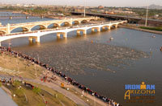

The ICTN Booth (pictured is Tom Keeley of Athletes in Action)
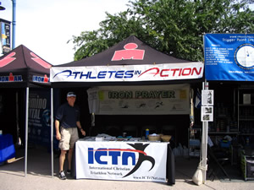

Small Group Prayer at Ironman Arizona Pre-Race Prayer Service
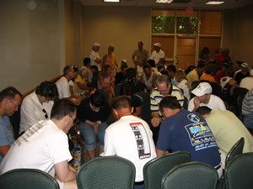

Ironman Arizona Prayer Crew: (from left to right) Tom Keeley – Athletes in Action; Stan Smith – Tri4Christ/FCA Endurance; pro triathlete Heather Gollnick; Lincoln Murdoch – Antioch Network/All Nations Church Racing; and, Scott Bennefield – Administrative Pastor, Hoffmantown Church, Albuquerque, New Mexico
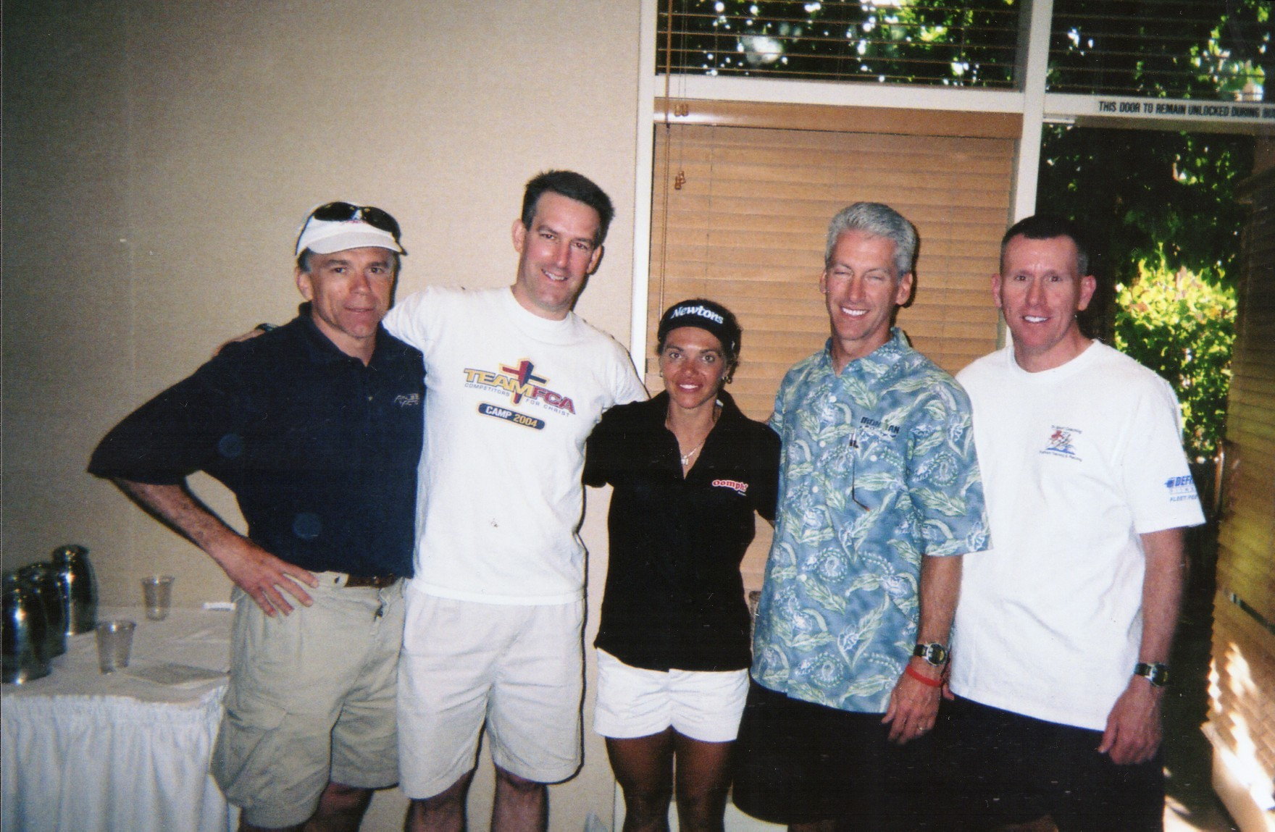

“Ironman” is a registered trademark of the World Triathlon Corporation.
For a reproduction of the entire prayer, see How a Man Prays for His Family, by John Yates (Minneapolis: Bethany House Publishers, 1996), pg. 133.
© 1999 Sparrow Song/Peach Hill Songs/BMI/Admin. By EMI Christian Music Publishing.
Thanks are due to many, many people who made this a success. I will try to list some of the names here, but it may not be possible to include a complete list. Any errors of omission are mine, and mine alone, and can in no way diminish the very real and necessary contributions of so many people (including the families of the athletes and the ICTN ministry representatives): Arva Bynum; Randy and Diane Shreckengast; Dan Ross; Dan Cadriel; Chris Winkler; D.R. Carlson; Matt Elliott; Marc Vaglio-Laurin; Kevin Weitzel – Tribe Multisport;
Grand Island, Nebraska: Cross Training Publishing, 2002.

